Atliq Employees Performance Data Analysis Project

About Project and what we have done:
This project gives us Atliq’s all employees presence for the months April , May and June (in the year 2022).
Insights drawn in this project:
- How many employees were present (in each month separately and across all months).
- For every month how many people preferred working from home.
- How many people were present , opted for Sick-leave and Work from home across all the 3 months (both by Day of week and Employee-code).
- Daily Attendance of all employees.
- KPIs for these data:
  - Total Working Days
  - Present Days
  - Presence %
  - Work from Home (abbreviated as WFH) %
  - Sick Leave (abbreviated as SL) %
- Trends observed in these data:
  - Highest attendance is observed to be in June
  - Most people preferred to work from Home in month of May.

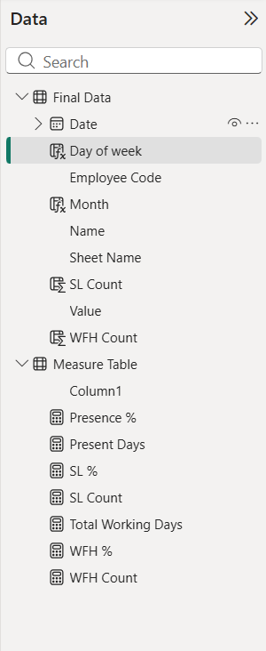

Measures used:
- WFH % = DIVIDE([WFH Count],[Present Days],0)*100
- Total Working Days =

VAR totaldays = COUNT('Final Data'[Value])

VAR nonworkdays = CALCULATE( COUNT('Final Data'[Value]),'Final Data'[Value] in {"WO","HO"})

RETURN totaldays - nonworkdays
- WFH Count = SUM('Final Data'[WFH Count])

- SL Count = SUM('Final Data'[SL Count])

- SL % = DIVIDE([SL Count],[Total Working Days],0)*100
- Present Days =

VAR Presentdays = CALCULATE(
COUNT('Final Data'[Value]), 'Final Data'[Value] = "P"
)

RETURN Presentdays + [WFH Count]

- Presence % = DIVIDE([Present Days],'Measure Table'[Total Working Days],0) * 100

New columns created:
- WFH Count = SWITCH(TRUE(),
'Final Data'[Value] = "WFH",1,
'Final Data'[Value] = "HWFH",0.5, 0)
- SL Count = SWITCH(TRUE(),
'Final Data'[Value] = "SL",1,
'Final Data'[Value] = "HSL",0.5, 0)
- Month = FORMAT('Final Data'[Date], "MMMM")

- Day of week = FORMAT('Final Data'[Date],"ddd")

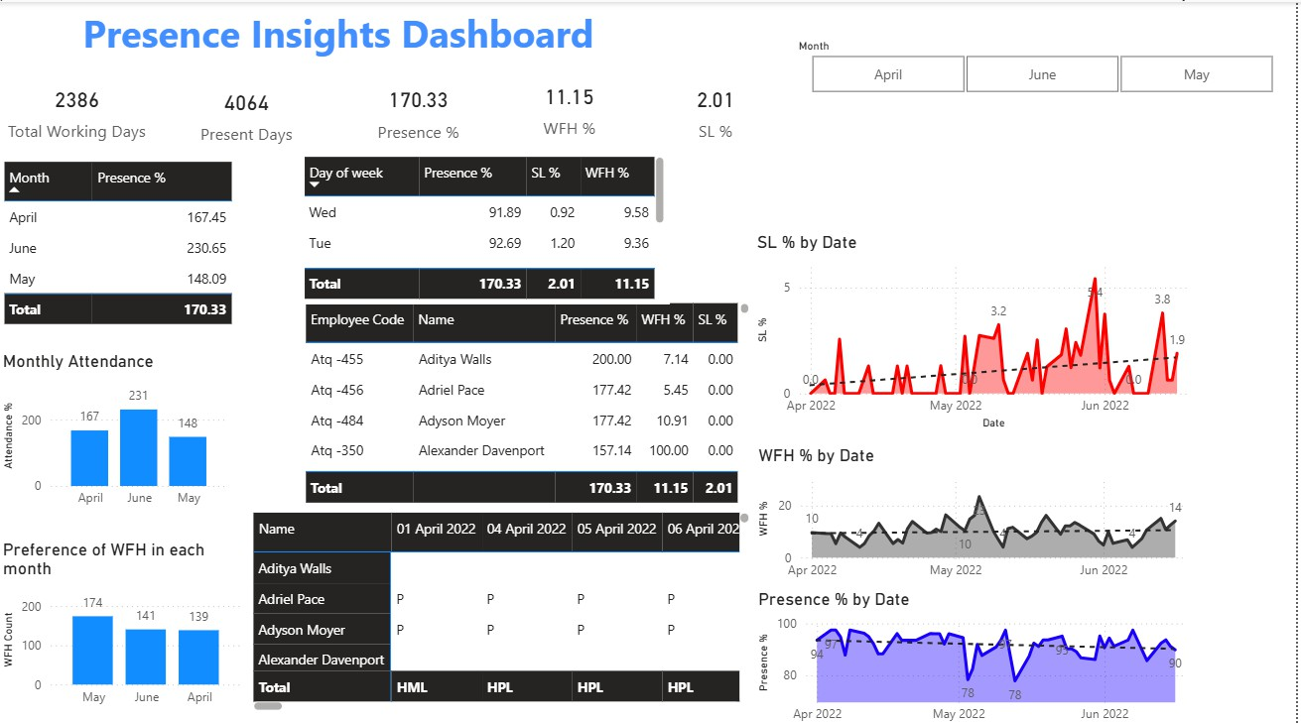
Final Dashboard:

Conclusion drawn:
- Sick-leaves are increasing with time
- Employees are not preferring to work from office with time (Since Presence % is decreasing)

